**URS & SRS**

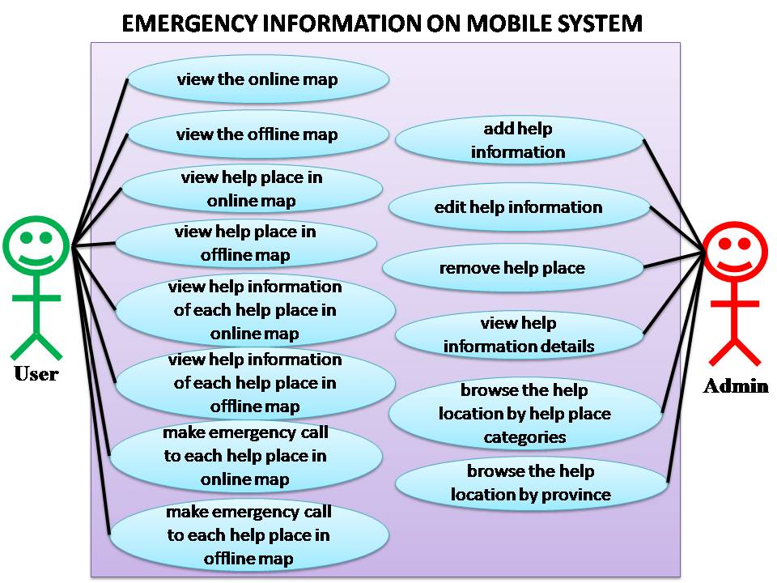

**• Feature 5**

[URS-1]: **The administrator can add help information, which includes name, address, phone number, and coordinate location.**

[URS-2]: The admin can edit help information which includes address, phone number, name, and coordinate location.

[URS-3]: The admin can remove help location.

[URS-4]: The admin can view help information of each help place.

[URS-5]: The admin can browse the help location by help place categories which are police station, highway police station, hospital, and garage.

[URS-6]: The admin can browse the help location by province of Thailand.

**• Feature 1**

[URS-7]: The user can view the online map with their current location.

[URS-8]: The user can view the offline map with their current location.

[URS-9]: The user can view the location of help place in online map.

[URS-10]: The user can view the location of help place in offline map.

[URS-11]: The user can view help information of each help place in online map.

[URS-12]: The user can view help information of each help place in offline map.

[URS-13]: The user can make emergency call to each help place in online map.

[URS-14]: The user can make emergency call to each help place in offline map.

**[URS-1]: The administrator can add help information, which includes name, address, district, province, zip code, phone number, and coordinates location.**

SRS-1: The system provides the UI which receive name, address, phone number, and coordinate location.

SRS-2: The system shall check the name length. The name must be 1- 50 characters.

SRS-3: The system shall check the address length. The address must be 0- 60 characters.

SRS-4: The system shall check the phone number format. The phone number should be 9-10 digits.

SRS-5: The system shall check the coordinate location format. The format must be decimal number of degrees, for example, 18.809011, 99.218742. The coordinate location format must not be empty.

SRS-: The system shall provide the map UI.

SRS-: The system shall add a new help location to the database using name, address, phone number, and coordinate location.

SRS-: The system shall provide the successful adding help information page.

SRS-: The system shall display the error message “The name length should be 1-50”

SRS-: The system shall display the error message “The phone number length should be 9-10”

SRS-: The system shall display the error message “Error! The coordinate format is wrong”

**[URS-2]: The admin can edit help information which includes address, phone number, name, and coordinate location.**

SRS-1: The system provides the UI which receive name, address, phone number, and coordinate location.

SRS-2: The system shall check the name length. The name must be 1- 50 characters.

SRS-3: The system shall check the address length. The address must be 0- 60 characters.

SRS-4: The system shall check the phone number format. The phone number should be 9-10 digits.

SRS-5: The system shall check the coordinate location format. The format must be decimal number of degrees, for example, 18.809011, 99.218742. The coordinate location format must not be empty.

SRS-: The system shall provide the map UI.

SRS-: The system shall update the help location to the database using name, address, phone number, and coordinate location.

SRS-: The system shall provide the successful adding help information page.

SRS-: The system shall display the error message “The name length should be 1-50”

SRS-: The system shall display the error message “The phone number length should be 9-10”

SRS-: The system shall display the error message “Error! The coordinate format is wrong”

**[URS-3]: The admin can remove help location.**

SRS-: The system shall provide UI to show list of help locations.

SRS-: The system shall retrieve the help information from system database.

SRS-: The system shall provide UI with message “Are you sure to delete?” to ask permission before remove help location.

SRS-: The system shall delete the help place out of the database.

**[URS-4]: The admin can view help information of each help place.**

SRS-: The system shall provide UI to show list of help locations.

SRS-: The system shall retrieve the help information from system database.

SRS-: The system shall show the help information which are name, address, phone number, coordinate, and rating score.

**[URS-5]: The admin can browse the help location by help place categories which are police station, highway police station, hospital, and garage.**

SRS-: The system shall provide categories UI which are police station, highway police station, hospital, and garage

SRS-: The system shall retrieve the help information from system database.

SRS-: The system shall show the list of help location by categories.

**[URS-6]: The admin can browse the help location by province of Thailand.**

SRS-: The system shall provide UI which province of Thailand.

SRS-: The system shall retrieve the help information from system database.

SRS-: The system shall show the list of help location by province.

**[URS-7]: The user can view the online map with their current location.**

SRS-: The system shall obtain the latitude and longitude of the user’s current location.

SRS-: The system shall provide online map UI, which shows online map with the user’s current location.

**[URS-8]: The user can view the offline map with their current location.**

SRS-: The system shall obtain the latitude and longitude of the user’s current location.

SRS-: The system shall provide offline map UI, which shows offline map with the user’s current location.

**[URS-9]: The user can view the location of help place in online map.**

SRS-: The system shall obtain the latitude and longitude of the user’s current location.

SRS-: The system shall provide online map UI, which shows the location of each help place around the user on the map.

**[URS-10]: The user can view the location of help place in offline map.**

SRS-: The system shall retrieve the loaded help information from the user’s device.

SRS-: The system shall provide offline map UI, which shows the location of each help place around the user on the map.

**[URS-11]: The user can view help information of each help place in online map.**

SRS-: The system shall retrieve the help information from the system database.

SRS-: The system shall provide information UI to show the help information, which are name, phone number and address.

**[URS-12]: The user can view help information of each help place in offline map.**

SRS-: The system shall retrieve the loaded help information from the user’s device.

SRS-: The system shall provide information UI to show the help information, which are name, phone number and address.

**[URS-13]: The user can make emergency call to each help place in online map.**

SRS-: The system shall provide the call UI.

SRS-: The system shall call to the selected help place.

**[URS-14]: The user can make emergency call to each help place in offline map.**

SRS-: The system shall retrieve the loaded help information from the user’s device.

SRS-: The system shall provide the call UI.

SRS-: The system call to the selected help place.